- Project Name:
Multifunction Standalone Access Control
- Introduction:
The device is a single door multifunction standalone Access controller or a Wiegand output reader. It uses Xtensa® dual-core 32-bit LX6 microprocessor assuring high and stabe performance. The operation is very user-friendly.
- Features:
  - PIN Lenght: 4~6 digits
  - Communacation: Wiegand Input*1, Wiegand-Output*1
  - Control Output: Electric Lock*1
  - Control Input: Door Sensor*1, Exit Button*1
- Operation Modes:
The device has 3 different operating modes.
Standalone Mode(Default Mode): The device can work as Standalone Access Control for single door.
Bu modda Wiegand Input/Output haberleşmesi olmayacak.
Digital Inputlar bu modda çalışacak.
1.Dig_In : Exit Button : Direkt olarak kapıyı açabilir.
2.Dig_In : Door Contact: Kapının Açık/Kapalı konumu algılamak için kullanacağız. Bu giriş LOW olduğunda kapı açık konumda olduğunu anlayacağız.
Controller Mode: The device can work as Controller, connected with the external Wiegand Reader.
Bu modun Standalone modundan tek farkı Wiegand girişinden harici bir reader bağlanabilecek.
Bu modda cihaza Wiegand girişinden harici bir Reader bağlanabilecek. Yani dahili inputları olan RFID, PIN ve QR okuyucularının yanı sıra, harici bağlanan Reader da UID gönderebilecek.
Bu mod set edildiğinde Wiegand Output Enable- Low a çekilmeli ki Wiegand direction-input olsun.
Cihaz bu moda set edildiği zaman "Menu 9" Wiegand Data Formats ayarlayabilecek. Bu data formats alınacak Wiegand paketlerinin formatı olacak.
Digital Inputlar bu modda çalışacak.
1.Dig_In : Exit Button : Direkt olarak kapıyı açabilir.
2.Dig_In : Door Contact: Kapının Açık/Kapalı konumu algılamak için kullanacağız. Bu giriş LOW olduğunda kapı açık konumda olduğunu anlayacağız.
Wiegand Reader Mode: The device can work as Standard Wiegand Reader, connected to the third party Controller.
Cihaz bu moda set edildiği zaman sadece "Menu 9" konfigürasyonu yapılabilecek. Yani Wiegand Data Formats ayarlanabilecek. Bu data formats gönderilecek Wiegand paketlerinin formatı olacak.
Çünkü cihaz bu modda inputlarından okuduğu ID leri hiç bir işlem yapmadan Wiegand Outputundan gönderecek.
Bunu yapmadan önce Wiegand Output Enable pinini High yapacak. Bu pin bu modda sürekli High olacak. Bunu Wiegand direction-Output olarak ayarlamak için yapacak.
Digital Inputlar bu modda çalışmayacak.
- Authentication Type:
  - Card via 13.56Mhz (Mifare M1 Card)
  - Touch PIN
  - QR Code
  - External Card Reader with Wiegand- Input(26-34bit)
  - External Button (Digital Input)
- Verification Type:
  - Local Database (Offline)
  - Uzak Sunucu (Wi-Fi) (Online)
- Hardware Specs:
  - Power Supply : 12V DC
  - Components
    - MCU: ESP32-WROOM-32E-N4
    - RFID: MFRC522 IC
    - Touch: TSM12 IC
    - QR: XR1300 Module
    - Shift Register: SN74HC595
    - Buzzer: without Circuit, driver with PWM
    - Relay
    - Wiegand Interface: Input- Output
    - Digital Inputs: 2 inputs
  - MCU Pin Configuration:
    - RFID:
      - MOSI: GPIO 5
      - MISO: GPIO 36
      - CLK: GPIO 15
      - CS: GPIO 0
      - IRQ: GPIO 35
      - RST: 74HC595-2-QG
    - Touch PIN (TSM12):
      - SDA: GPIO 32
      - SCL: GPIO 33
      - INT: GPIO 14 (Interrupt output from TSM12)
      - OUT: GPIO 27
      - RST: 74HC595-1-QD
    - QR Code Reader (XR1300):
      - TX: GPIO 25 (Connect to QR Reader RX)
      - RX: GPIO 39 (Connect to QR Reader TX)
    - Shift Register Digital (SN74HC595):
      - CLK (SHCP): GPIO 4
      - DATA (DS): GPIO 16
      - LATCH 1 (STCP for First Block): GPIO 17
      - LATCH 2 (STCP for Second Block): GPIO 13
    - Wiegand Interface :
      - D0 (Data 0): GPIO 22 (Input/Output capable logic)
      - D1 (Data 1): GPIO 23 (Input/Output capable logic)
    - Digital Input (e.g., Door contact, Exit Request button):
      - Input-1: GPIO 19
      - Input-2: GPIO 21
    - Buzzer:
      - PWM Output: GPIO 2
    - Relay:
      - Relay-EN: 74HC595-2-QH
    - Addresable RGB Led(WS2812B):
      - Data IN: GPIO 12
    - Shift Register-Outputs (SN74HC595 x2):
      - SN74HC595-1
        - QA: LED_EN_9
        - QB: LED_EN_1
        - QC: LED_EN_4
        - QD: TSM_RST
        - QE: LED_EN_5
        - QF: LED_EN_6
        - QG: LED_EN_3
        - QH: LED_EN_2
      - SN74HC595-2
        - QA: LED_EN_8
        - QB: LED_EN_10
        - QC: LED_EN_7
        - QD: LED_EN_11
        - QE: LED_EN_12
        - QF: Wiegand Output Enable
        - QG: RFID_RST
        - QH: Relay-EN
- Sound and LED Indication
Operation Status | LED | Buzzer
Stand by | Red light bright
Enter into programming Mode | Red light bright | One beep
In the programming Mode | Orange light bright | One beep
Operation Error | Red light shines | Three beeps
Exit from the Programming Mode | Red light bright | One beep
Open Lock | Green light bright | One beep
Alarm | Red light Shines quickly | Beeps

  - Working
After the access controller is powered on, its LED status indicator turns green and blinks for 1 time firstly. Then it turns red and blinks for 3 times, and the buzzer buzzes a beep sound indicating the initialization process is completed.
When using the access control terminal, it will send out different sound prompt and the LED indicator on it has different statues. For the detailed information, refer to the table below.
Sound Promt | LED Indicator | Description
 | Green and Blinking Slowly | The access controller is working normally.
One Beep | Solid Green | Pressing keys prompt, Swiping card prompt, Swiping QR prompt
Two Rapid Beeps | Solid Red | The operation of pressing keys, swiping card or swiping QR valid.
Three Slow Beeps |  | The operation of pressing keys, swiping card or swiping QR invalid.
Two Rapid Beeps |  | The operation of entering the programming mode is succesful.
Three Slow Beeps |  | The operation of entering the programming mode is failed.
Beep for 10 Seconds |  | Delayed door alarm (the door is opened over the time limitation)

  - Programming Mode
After entering the programming mode, LED status indicator turns blue and blinks rapidly.
After exiting the programming mode(with "*") , the buzzer buzes two rapid beeps for switching the programming mode to the normalde mode.
    - Update Master Code
The sound and LED scenarios that can be applied while the user is performing an operation in Programming mode, Sub-Menu-0, are as shown in the table below.

Sound Promt | LED Indicator | Description
3 Slow Beeps | Solid red during the beeps | The operation of update master code is failed
2 Rapid Beeps | Solid green during the beeps | The operation of update master code is successful

    - Add Master Card
The sound and LED scenarios that can be applied while the user is performing an operation in Programming mode, Sub-Menu-1, are as shown in the table below.

Sound Promt | LED Indicator | Description
3 Slow Beeps |  | Enter another user ID for the current user ID has been applied
2 Rapid Beeps |  | The user ID is valid, wait for swiping
1 Beep |  | Swipe the card or QR

    - Add User
The sound and LED scenarios that can be applied while the user is performing an operation in Programming mode, Sub-Menu-2, are as shown in the table below.

Sound Promt | LED Indicator | Description
3 Slow Beeps | Solid yellow during the beeps | Enter another user ID for the current user ID has been applied
2 Rapid Beeps | Solid green during the beeps | The user ID is valid, wait for swiping
1 Beep |  | Swipe the card or QR

When adding cards continuously, different beeps stand for different meanings.
Sound Promt | LED Indicator | Description
1 Beep |  | Swipe the card or QR
5 Slow Beeps | Solid red during the beeps | The card or QR is failed to be added for it has been registered
3 Slow Beeps | Solid yellow during the beeps | The user ID exists
2 Rapid Beeps | Solid green during the beeps | The card or QR is successfully added

    - Delete User
The sound and LED scenarios that can be applied while the user is performing an operation in Programming mode, Sub-Menu-3, are as shown in the table below.

Sound Promt | LED Indicator | Description
3 Slow Beeps | Solid red during the beeps | The operation of deleting card or QR is failed
2 Rapid Beeps | Solid green during the beeps | The operation of deleting card or QR is successful
1 Beep |  | Swipe the card or QR

    - Set Relay Configuration
The sound and LED scenarios that can be applied while the user is performing an operation in Programming mode, Sub-Menu-4, are as shown in the table below.

Sound Promt | LED Indicator | Description
3 Slow Beeps | Solid red during the beeps | The operation of deleting card or QR is failed
2 Rapid Beeps | Solid green during the beeps | The operation of deleting card or QR is successful
1 Beep |  | Swipe the card or QR

    - Set Access Mode
The sound and LED scenarios that can be applied while the user is performing an operation in Programming mode, Sub-Menu-5, are as shown in the table below.

Sound Promt | LED Indicator | Description
3 Slow Beeps | Solid red during the beeps | The relay time failed to be set between 1-99
2 Rapid Beeps | Solid green during the beeps | The relay time was successfully set to between 1-99
1 Beep |  | The relay set to ON toggle Mode succesfully

    - Set the Working Mode
The sound and LED scenarios that can be applied while the user is performing an operation in Programming mode, Sub-Menu-6, are as shown in the table below.

Sound Promt | LED Indicator | Description
3 Slow Beeps | Solid red during the beeps | The working mode setting to failed
2 Rapid Beeps | Solid green during the beeps | The working mode has been successfully set
1 Beep |  | Choose one of the operating modes

    - Set Open Door Detection
The sound and LED scenarios that can be applied while the user is performing an operation in Programming mode, Sub-Menu-7, are as shown in the table below.

Sound Promt | LED Indicator | Description
3 Slow Beeps | Solid red during the beeps | The open door detection setting to failed
2 Rapid Beeps | Solid green during the beeps | The open door detection has been successfully set
1 Beep |  | Set the open door detection to on/off

    - Set Audible and Visual Response
The sound and LED scenarios that can be applied while the user is performing an operation in Programming mode, Sub-Menu-8, are as shown in the table below.

Sound Promt | LED Indicator | Description
3 Slow Beeps | Solid red during the beeps | The Sound and Led operation setting to failed
2 Rapid Beeps | Solid green during the beeps | The Sound and Led operation successfully setting
1 Beep |  | Set the Sound and Led operation

    - Set Wiegand Input-Output Formats
The sound and LED scenarios that can be applied while the user is performing an operation in Programming mode, Sub-Menu-9, are as shown in the table below.
Sound Promt | LED Indicator | Description
3 Slow Beeps | Solid red during the beeps | The Wiegand Input/Output bits setting to failed
2 Rapid Beeps | Solid green during the beeps | The Wiegand Input/Output bits successfully setting
1 Beep |  | Set the Wiegand Input/Output bits

- Reset
Cihazın arkasında bulunan “Reset” butonuna 5 saniye basılı tutularak reset işlemi gerçekleştirilir. Reset işleminden sonra cihaz hafızasında bulunan Wi-Fi bilgileri, tüm UserID ve USERPIN kayıtları, Master Card kayıtları silinir. MasterCode Default değeri “123456” değerine döner.

- Basic Programming
  - Enter and Exit Program Mode
Programming Step | Keystroke Combination
Enter Program Mode | ✶→ (Master Code) → #  (Factory default ise 123456)
Exit Program Mode | *

  - Set Master Code
Programming Step | Keystroke Combination
1.Enter Program Mode | ✶→ (Master Code) → #  (Factory default ise 123456)
2.Update Master Code | 0 → (New Master Code) → # → (Repeat New Master Code) → #  (Master code is any 6 digits)
3.Exit Program Mode | *

  - Set the Working Mode
Notes: The device has 3 working modes:Standalone Mode, Controller Mode and Wiegand Reader Mode, choose the mode you use. (Factory default is Standalone Mode)
Programming Step | Keystroke Combination
1.Enter Program Mode | ✶→ (Master Code) → #
2.Standalone Mode  2.Controller Mode  2.Wiegand Reader Mode | 6 → 7 → # (Factory Deafult)  6 → 8 → #  6 → 9 → #
3.Exit Program Mode | *

- OFFLINE OPERATION (Offline Mode)
  - Standalone Mode
The device can work as Standalone Access Control for single door.
(Factory default mode) - 67#
    - Connection Diagram Common Power Supply
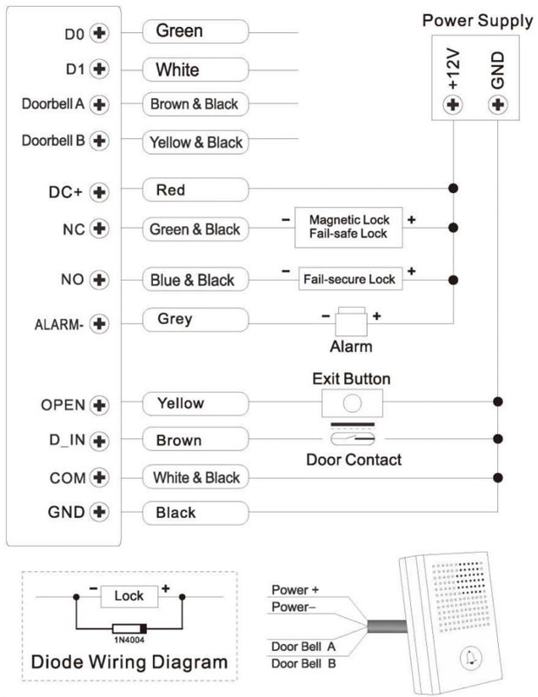
    - Programming
Programming will be vary depending on Access configuration. Follow the instructions according to your Access configuration.
Notes:
- UserID number: Assign a user ID to the Access card / PIN in order to track it.
- UserID number:
The Common Card/ PIN User ID: 1-9988
IMPORTANT: User IDs do not have to be proceeded with any leading zeros. Recording of User ID is critical. Modifications to the user require the User ID be available.
- Proximity Card: Mifare Card
- PIN: Can be any 4~6 digits.
- QR: Support

    - Add Master Card
Programming Step | Keystroke Combination
1.Enter Program Mode | ✶→ (Master Code) → #
Add Card Master
2.Using Master ID (Allows the device to assign Card to next available Master ID number) OR | 1 → Read Card → #  1 → Input 8/10/17 Digits Card Number → #  The cards can be added contionusly.
2.Using Specific ID (Allows Master to define a specific Master ID to associate the card to) OR | 1 → Master → # → Read Card → #  1 → Master → # → Input 8/10/17 Digits Card Number → #
3. Exit | *

    - Add Users
(PIN / Card / QR user ID: 1-9988; PIN lenght: 4~6 digits)
Programming Step | Keystroke Combination
1.Enter Program Mode | ✶→ (Master Code) → #
Add Card User
2.Using Auto ID (Allows the device to assign Card to next available User ID number) OR | 2 → Read Card → #  2 → Input 8/10/17 Digits Card Number → #  The cards can be added contionusly.
2.Using Specific ID (Allows Master to define a specific User ID to associate the card to) OR | 2 → UserID → # → Read Card → #  2 → UserID → # → Input 8/10/17 Digits Card Number → #
2. Add Card: Block Enrollment (Allow Master to add up to 200 cards to the Reader in a single step) Takes 2 minutes to program. | 2 → UserID → # → Card Quantity → # → The First Card 8/10/17 Digits Number → #  Card’s number must be consecutive;  Card quantity = number of cards to be enrolled.
Add PIN User
2.Select Specific ID (Allows manager to define a specific User ID to associate the PIN to) | 2 → UserID → # → PIN → #
3. Exit | *
Note: Users are added via the mobile application for QR code access.
Tips for PIN Security (Only validfor 6digits PIN):
For higher security we allow you to hide your correct PIN with other numbers up to a max of 10 digits.
Example PIN: 123434
You could use **(123434) ** or ** (123434)
(“*”can be any numbers from 0~9)
    - Change PIN Users (PIN lenght: 4~6 digits)
Programming Step | Keystroke Combination
Note: Below is done outside programming modei users can undertake this themselves
Change PIN | ✶ → UserID → # → OldPIN → # → NewPIN → # → Repeat NewPIN → #

    - Delete Users
Programming Step | Keystroke Combination
Entering the Programming Mode | ✶ → MasterCode → #
2. Delete User – by Read Card  OR  2. Delete User – by ID  OR  2. Delete User – by CardNumber  OR  2. Delete ALL Users | 3 → ReadCard → #  The users can be deleted continuously  3 → UserID → #  3 → Input 8/10/17 Digits Card Number → #  3 → Master Code → #
Exit | ✶

    - Set Relay Configuration
Programming Step | Keystroke Combination
Entering the Programming Mode | ✶ → MasterCode → #
2. Pulse Mode  OR  2. Toggle Mode | 4 → 1~99 → # (Factory Default)  The relay time is 1-99 seconds.  Default is 5 seconds.  4 → 0 → #  Sets the relay to ON/OFF Toggle mode
Exit | ✶

    - Set Access Mode
Programming Step | Keystroke Combination
Entering the Programming Mode | ✶ → MasterCode → #
2. Card Access  OR  2. PIN Access  OR  2. QR Access  OR  2. Card or PIN Access  OR  2. Card or QR Access  OR  2. PIN or QR Access  OR  2. Card, PIN or QR Access | 5 → 0 → #  5 → 1 → #  5 → 2 → #  5 → 3 → #  5 → 4 → #  5 → 5 → #  5 → 6 → # (Factory Default)
Exit | ✶

    - Set Open Door Detection
Programming Step | Keystroke Combination
Entering the Programming Mode | ✶ → MasterCode → #
2. Disable Door Open Detection  OR  2. Enable Door Open Detection Set Alarm Time | 7 → 3 → # (Factory Default)  7 → 4 → 0~3(Factory Default is 1 minutes) → #
Exit | ✶

    - Set Audible and Visual Response
Programming Step | Keystroke Combination
Entering the Programming Mode | ✶ → MasterCode → #
2. Disable Sound  OR  2. Enable Sound  OR  2. Led Always OFF  OR  2. Led Always ON | 8 → 0 → #  8 → 1 → # (Factory Default)  8 → 2 → #  8 → 3 → # (Factory Default)
Exit | ✶

    - Master Card Usage
Using Master Card to ADD and DELETE user
Add Card / PIN Users | 1. Read the Master Card.  2. Read User Card or UserID → # → PIN → #  Repeat step 2 for additional users.  3. Read the Master Card again.
Delete Card / PIN Users | 1. Read the Master Card Twice within 5sec.  2. Read User Card or UserID → #  Repeat step 2 for additional users.  3. Read the Master Card again.

    - Users Opearation & Reset to Factory Default
      - Open the door: Read Valid User Card or Input Valid UserPIN → #
      - Remove Alarm: Enter MasterCode → # or Read Master Card or Valid User Card or Enter UserPIN
      - To reset to factory default & Add Master Card: Triggered by entering '0' five times on the keypad within the first 10 seconds after power-on.
  - CONTROLLER MODE
The device can work as Controller, connected with the external Wiegand reader.
- 77#
    - Connection Diagram
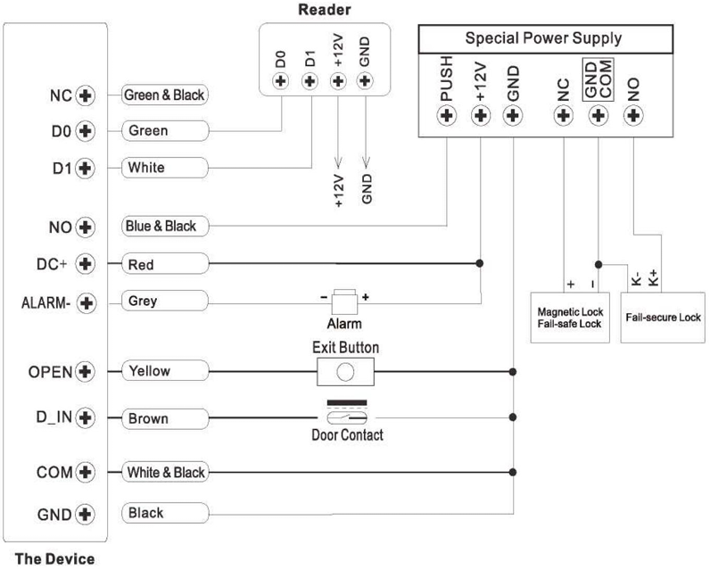
    - Set Wiegand Input Formats
Programming Step | Keystroke Combination
Enter the Programming Mode | * → Master Code → #
2. Wiegand Input bits | In programming mode  For 26bits 9 → 26 → #  For 34bits 9 → 34 → #  (Factory Default is 34bits)
Exit from the Programming Mode | *

    - Programming
Basic Programming is the same as Standalone Mode
  - WIEGAND READER MODE
The device can work as Standard Wiegand Reader, connected to the third party Controller — 78#
    - Connection Diagram
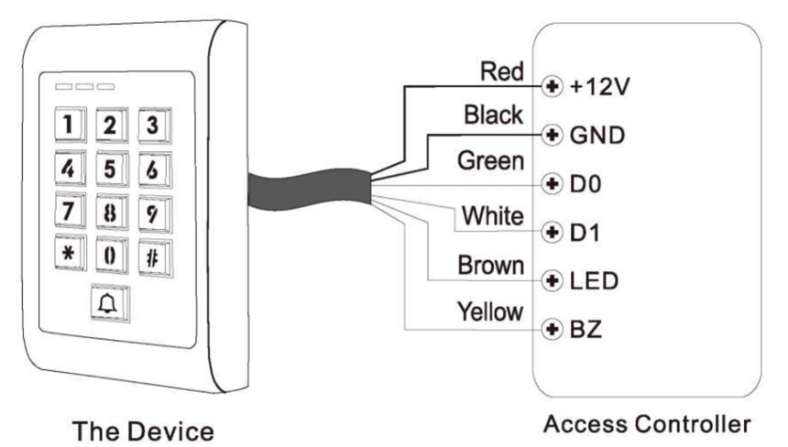
Notes:
- When set into Wiegand Reader Mode, nearly all settings in Controller Mode will become invalid, and Brown & Yellow wires will be redefined as below:
- - Brown wire: Green LED light control
- Yellow wire: Buzzer Control
If you need to connect Brown/Yellow wires:
When the input voltage for LED is low, the LED will turn into Green; and when the input voltage for Buzzer is low, it will sound.
    - Set Wiegand Output Formats
Programming Step | Keystroke Combination
Enter the Programming Mode | * → Master Code → #
2. Wiegand Output bits | In programming mode  For 26bits 9 → 26 → #  For 34bits 9 → 34 → #  (Factory Default is 34bits)
Exit from the Programming Mode | *

Simplified Instruction
Function Description | Operation
Enter the Programming Mode | * → Master Code → #  then you can do the programming.  (Factory default MasterCode is 123456)
Change the Master Code | 0 → New Code → # → Repeat the New Code → #  (code: 6 digits)
Add Card User | In programming mode  1 → Read Card → #  OR 1→ Input 8/10/17 Digits Card Number → #  (can add cards continuously)
Add PIN User | In programming mode  1 → UserID → PIN #  The PIN is any 4~digits
Add QR User | In programming mode  2 → QR Code → #  (can add QR continuously)
Delete User | In programming mode  2 → Read Card → #  2 → UserID → #  2 → QR Code → #
Exit from the Programming Mode | *
How to Release the Door
Card User | Read Card
PIN User | Input PIN → #
QR User | Read QR

- ONLINE OPERATION (Online Mode)
BLE (BLUETOOTH LOW ENERGY) PROTOKOLÜ : Bluetooth privisioning işlemini daha önce yazılıma eklemiş olabiliriz. Kontrol et.
Bu bölüm, cihazın mobil uygulama ile Bluetooth Low Energy (BLE) üzerinden gerçekleştirdiği eşleşme ve Wi-Fi yapılandırma protokolünü tanımlar.
  - Bluetooth
    - BLE Anahtar Kavramlar
•deviceId: deviceId parametresi cihazın benzersiz kimliğini temsil eder.
•pairKey / deviceKey: BLE eşleşmesi sırasında üretilen çift ve cihaz anahtarlarıdır; sonraki HTTP isteklerinde kullanılır.
•macAddress: Cihazın MAC Adresidir.
•rssi: Kablosuz ağın sinyal gücünü belirtir (Received Signal Strength Indicator).
•frequency: Kablosuz ağın frekans bandını belirtir (2.4 GHz, 5 GHz).
•name: Kablosuz ağın adıdır (SSID).
Bluetooth Name ve DeviceID için aşağıdaki konfigürasyonu kullanalım:
String ble_name;
void initDeviceId() {
// WiFi.macAddress() bazen 0 dönebilir, bu yüzden EfuseMac kullanıyoruz.
uint64_t chipid = ESP.getEfuseMac();

char idStr[32];
// chipid'nin alt 3 byte'ını (24 bit) alarak unique ID oluştur.
// Genellikle MAC adresinin son kısmına denk gelir.
uint32_t low = (uint32_t)chipid;
sprintf(idStr, "SMART_%06X", (low & 0xFFFFFF)); // SMART_XXXXXX formatı
device_id = String(idStr);
char nameStr[64];
sprintf(nameStr, "Onloi_%s", idStr);
ble_name = String(nameStr);
DEBUG_PRINT("Generated Device ID: ");
DEBUG_PRINTLN(device_id);
DEBUG_PRINT("Generated BLE Name: ");
DEBUG_PRINTLN(ble_name);
}
    - BLE Komut Değerleri
handshake : Bağlantı kurulumu sırasında gerçekleştirilen kimlik doğrulama sürecidir.
pair : Uygulama ile cihaz arasında güvenli bağlantı kurmak için kullanılır.
getSsids : Kullanılabilir Wi-Fi ağ listesini (SSID) çeker.
connectWifi : Wi-Fi bağlantısının kurulup kurulmadığını kontrol eder.
    - Tarama
Cihaz, keşfedilebilir modda tutulmalıdır. Cihaz yalnızca ilk eşleşme sırasında veya kullanıcı fabrika ayarlarına sıfırlama yaptıktan sonra görünür olmalıdır. Cihaz adı "Onloi Lock" olarak yayınlanır; böylece Mobil App bunu bir Onloi cihazı olarak tanıyabilir.
    - Bağlanma
Bağlantı, iki cihaz arasında otomatik olarak kurulur; herhangi bir hazırlık gerekmez.
    - Servis Keşfi
Bağlantı kurulduktan sonra Mobil App, Cihaz'ın servis ve karakteristiklerini sorgular. Cihaz, bağlantı gerçekleşir gerçekleşmez servis ve karakteristik bilgilerini Mobil App e gönderir.
    - El Sıkışma (handshake)
Adım 1 — Mobil App, bağlantı kurulduğunda Cihazın bir karakteristiğine aşağıdaki JSON'u yazar:
{
"command": "handshake"
}
Adım 2 — Cihaz, yanıt olarak aşağıdaki JSON'u bir karakteristik üzerinden Mobil App gönderir:
{
"command": "handshake",
"deviceId": "<string>",
"createdAt": <timestamp>
}
    - Eşleşme (Pair)
Adım 1 — Mobil App, Cihazın bir karakteristiğine aşağıdaki JSON'u yazar. Cihaz, "deviceKey" ve "pairKey" değerlerini sonraki HTTP istekleri için kaydeder:
{
"command": "pair",
"deviceKey": "<string>",
"pairKey": "<string>"
}
//Adım 2 — Cihaz, yanıt olarak aşağıdaki JSON'u Mobil App e gönderir:
{
"command": "pair",
"result": "succeeded" | "failed"
}
    - Cihazı Wi-Fi’a Bağlama
Adım 1 — Mobil App, SSID listesi almak için Cihaza aşağıdaki JSON'u yazar:
{
"command": "getSsids"
}
//Adım 2 — Cihaz, kullanılabilir Wi-Fi ağlarını listeler:
{
"command": "getSsids",
"result": {
"0": {
"macAddress": "<string>",
"rssi": <number>,
"frequency": 2.4 | 5 | 6,
"name": "<string>"
}
}
}
//Adım 3 — Mobil App, seçilen ağa bağlanmak için Cihaza aşağıdaki JSON'u yazar:
{
"command": "connectWifi",
"ssid": "<string>",
"macAddress": "<string>",
"pass": "<string>"
}
//Adım 4 — Cihaz, bağlantı sonucunu bildirir:
{
"command": "connectWifi",
"result": "succeeded" | "failed"
}
  - HTTP Tabanlı JSON Haberleşme Protokolü
    - İletişim Akışı
https://api.onloi.com/api/device/runtime)
Cihaz ← Komutlar ← Server (https://api.onloi.com/api/device/runtime)
Cihaz → CMD_Response → Server (https://api.onloi.com/api/device/runtime)
    - Temel Parametreler
Parametre - Tür - Açıklama
deviceId - string - Cihazın benzersiz kimlik numarasıdır. SMART_XXXXXX şeklinde ön eki bulunur.
pairKey - string - BLE eşleşmesi sırasında üretilen çift anahtarı; her HTTP isteğinde gönderilir
deviceKey - string - BLE eşleşmesi sırasında üretilen cihaz anahtarı; her HTTP isteğinde gönderilir
command - string - İstek türünü belirten komut anahtar kelimesi
data - mixed - Komuta göre değişen veri alanı (string veya number)
    - Ortak http İstek Bilgileri
Method: POST
URL: https://api.onloi.com/api/device/runtime
Content-Type: application/json
Kimlik Doğr.: pairKey + deviceKey — istek gövdesinde taşınır
    - Ortak İstek Gövde Şablonu
{
"action": "run",
"name": "device",
"args": {
"command": "<komut>",
"pairKey": "<string>",
"deviceKey": "<string>",
"deviceId": "<string>",
"data": "<değer>",
"createdAt": <unix_ms>
}
}
    - Doğrulama / Şifre – Kart Sorgulama
Cihaz, girilen geçici bir parolayı (Tuş takımı vs.) veya okutulan bir UID'yi (Kart vb.) doğrulamak için sunucuya sorar.

Desteklenen Veri (data) Tipleri:
KEYPAD:123456 (Şifre girildiğinde)
RFID:AABBCCDD (Kart/UID okutulduğunda)
FINGERPRINT:1 (Parmak izi okutulduğunda)
QR:Veri (QR kod okutulduğunda)
İstek (JSON):
json
{
"action": "run",
"name": "device",
"args": {
"command": "pass",
"data": "RFID:AABBCCDD",
"devicekey": "...",
"deviceid": "SMART_XXXXXX",
"createdat": 1700000000000,
"pairKey": "..."
}
}
Sunucu Yanıtı:
HTTP 200 OK: Geçerli / Yetkili (kapı açılır.)
HTTP 403 Forbidden: Yetkisiz / Geçersiz. (Kapı Açılmaz)
Diğer Hatalar: Cihaz durumu OFFLINE ya da ERROR olarak işaretlenir.

Sunucu üzerinden HTTP 200 OK dönmesiyle işlem döngüsü tamamlanmış olur.
    - Komut Özet Tablosu
event_log - ESP32 → Server - Erişim olaylarını (kapı açma, hata vb.) sunucuya iletir
cmd_response - ESP32 → Server - Sunucudan gelen komutlara işlem sonucunu bildirir
set_language - Server → ESP32 - Kilidin bildirim dilini ayarlar
find_device - Server → ESP32 - Kilidi sesli/titreşimli konumlandırır (beep)
query_settings - Server → ESP32 - Mevcut ses ve dil ayarlarını sorgular
query_time - Server → ESP32 - Güncel UTC zamanını ESP32'ye sorgular
factory_reset - ESP32 → Server - Cihaz fabrika sıfırlamasını sunucuya bildirir

